**Solution Architecture:**

|  |  |
| --- | --- |
| Date | 01 November 2022 |
| Team ID | PNT2022TMID22839 |
| Project Name | IoT based smart crop protection system foe agriculture |
| Maximum Marks | 4 Marks |

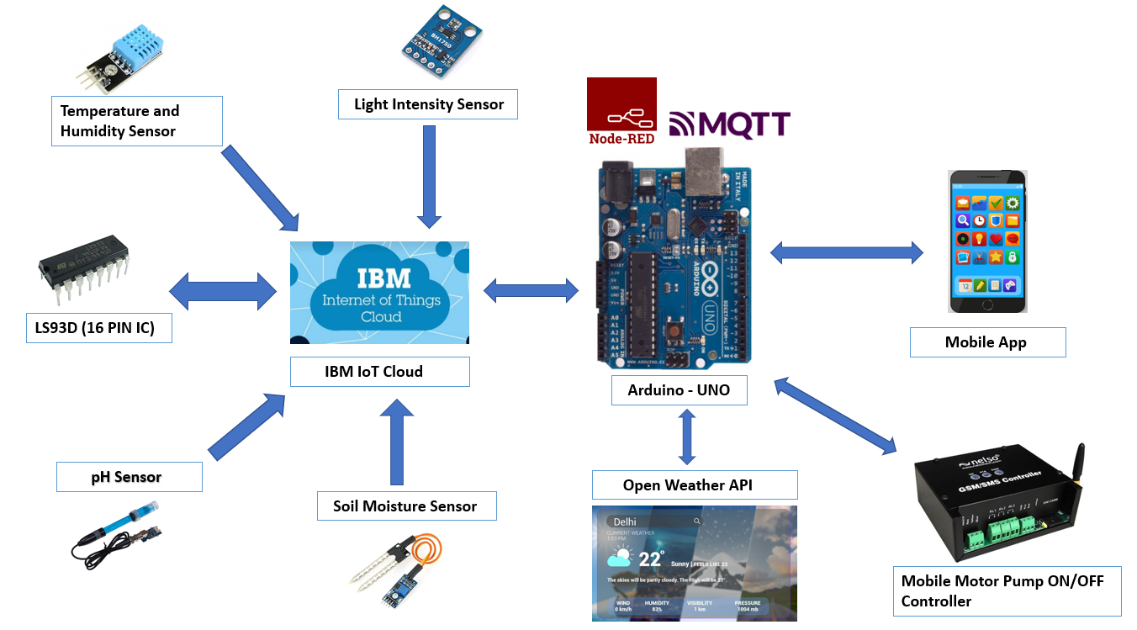

|  |
| --- |
| Key points:  •  The different soil parameters (temperature, humidity, light intensity, pH level) are sensed using different sensors and the obtained value is stored in IBM cloud.  •  Arduino uno is used as a processing unit which processes the data obtained from sensors and weather data from weather API.  •  Node red is used as a programming tool to wire the hardware, software and APIs. The MQTT protocol is followed for communication.  •  All the collected data are provided to the user through a mobile application which was developed. Depending upon the sensor values, Mobile Motor Pump controller waters the crop. |